User-centered design in video game online distribution

Inspecting the features of Epic Games Store

Tony Heikkilä  
 Department of Computer Science  
 University of Eastern Finland  
 Kuopio, Northern Savo, Finland  
tonhei@student.uef.fi

Jukka Arponen  
 Department of Computer Science  
 University of Eastern Finland  
 Kuopio, Northern Savo, Finland  
 jparpone@student.uef.fi

Antti Auvinen  
 Department of Computer Science  
 University of Eastern Finland  
 Kuopio, Northern Savo, Finland  
 antauv@student.uef.fi

Matti Auvinen  
 Department of Computer Science  
 University of Eastern Finland  
 Kuopio, Northern Savo, Finland  
 [mattiau@uef.fi](mailto:email@email.com)

Juhana Ullgren  
 Department of Computer Science  
 University of Eastern Finland  
 Kuopio, Northern Savo, Finland [juhanau@student.uef.fi](mailto:juhanau@student.uef.fi)

ABSTRACT

Online gaming platforms offer gamers the possibility of purchasing games as well as containing functions for social interactions. There are currently many different gaming platforms with varying functionalities. Some of these platforms have existed for many years and have grown to be well liked by the users. The focus of this report was on an online gaming platform called Epic Games Store. As a new service it has had some usability issues that we address later in this report. We gathered information from users of online gaming platforms. A questionnaire was performed to find what were the most requested and important features of an online gaming platform. We also made timed tests on the existing Epic Games Store, asking users to time some basic actions on the current Epic Games Store. We found that Epic Games Store has much room for improvement. Based on the questionnaire we also made mock-ups of possible improvements. We then used the information gathered to generate personas that use online gaming platforms. Our mock-up ideas made improvements to the usability of the platform while maintaining its simplistic style and clean outlook. We also found and identified many missing features that users want and need.

CCS CONCEPTS

• Human computer interaction (HCI)• Interaction design   • User-Centered Design

KEYWORDS

User-centered design, Video game online distribution, Video game platform, Online store menus

ACM Reference format:

Tony Heikkilä, Jukka Arponen, Antti Auvinen, Matti Auvinen and Juhana Ullgren. 2020. User-centered design in video game online distribution: Inspecting the features of Epic Games Store.

INTRODUCTION

Epic Games company was founded in 1991. They have made many popular games in the past such as Gears of War and Unreal Tournament. Their greatest success came in 2017 when they created Fortnite Battle Royale. Fortnite is a popular addition to the already massively successful genre of games called Battle Royale. In a Battle Royale game, players are dropped into a map that contains weapons and equipment. Players must arm themselves and eliminate one another until only the winner of the match remains. The genre combines scavenging, survival, exploration, and combat in a way that has really caught the attention of players worldwide. According to some sources, Fortnite Battle Royale has around 350 million accounts [1] with a record of 78.3 million monthly players [2]. This makes the game extremely popular and very profitable.

Following the success of their Fortnite game, Epic Games also created an online gaming store called Epic Games Store. Epic Games store was launched in 2018. The focus of this project was to find ways to improve the usability of the Epic Games Store. It was discovered that Epic Games Store has quite a minimalistic and clean looking overall appearance. There are not too many buttons and it has been designed with a simplistic style. However, some features that have been liked by many players on other gaming platforms have been missing for quite some time. A study was made on Google Forms to discover the most requested features by some of the gaming community, mostly friends of the makers of this document. The results of the study shall be more closely displayed on a later section of this document.

Steam is a popular online gaming platform. It was launched in 2003 and has been in constant development ever since. Steam has quite a complex user interface with many buttons and functions. Despite being more complicated than Epic Games Store, it also has very good coverage on important things, the things that users value. Epic Games Store will have quite a workload ahead of them, trying to catch up this fifteen-year head start that Steam has. To this day, Epic Games Store is still missing some very important features that other platforms already have. How should they decide the order in which new features are added? How should they copy the features that users demand while maintaining their simplistic and clean style? This document aims to bring attention to some of the key usability things users want and need in the future. And hopefully suggest some much needed improvements.

DATA COLLECTION

Due to current situation with the COVID-19 quarantine the data gathering was decided to be done remotely. The first interviewing was done with Google Forms, where a user can answer questions freely on their own time, wherever and whenever they want. An interaction design book mentions questionnaires are a good tool for collecting opinions and demographic data [3]. The low threshold questionnaire was a way to increase participant count so more in-depth analysis could be done. Google Forms is being used as a platform widely, so the format was probably familiar to the participants. The form was shared to other Computer Science students and to our friends. The form was answered by 11 participants.

Participants' sex and age were asked in the survey to see differences in taste and user experiences in different demographics. The information was used to create two user personas based on the survey data. The participants were also asked on which platform they play games. Meaningful features selected on the later stage of the survey could have vary based on users’ experience with different gaming platforms, since most of the digital distribution platforms operate on Windows platform. Users were also asked whether they had used Epic Games Store earlier and how would they rate this user experience. Other video game digital platforms were also introduced in the questionnaire and the users were asked to select the ones they had used.

SURVEY RESULTS

All responders were male, but this may be because of a) males tend to play video games more b) participants were likely the friends of the all-male project group c) most of the students in User-Centered Design course and other Computer Science courses are male. Age distribution was 21-25 years old (45.5%), 26-30 years old (27.3%) and 31-40 years old (27.3%). Again, this participant group represents most of the Computer Science students - young male adults. Most of the participants played video games on PC (90.9%), but they also had experiences playing on different platforms: PlayStation (45.5%), Xbox (18.2%), Nintendo (18.2%), Mobile (18.2%).

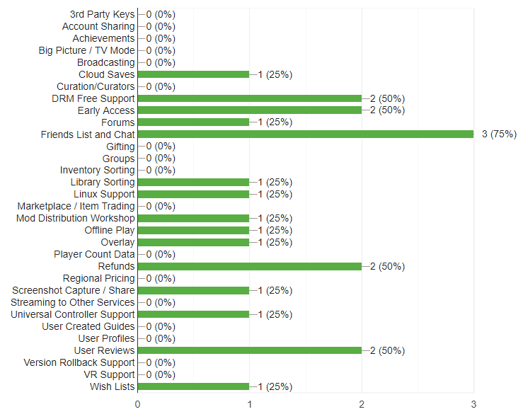

Figure 1: Selected features from users who had previous experience with the Epic Games Store.

7 out of 11 participants (63.6%) did not have previous experience with Epic Games Store. These users rated their experience with Epic Game Store with grades 2 (one participant), 3 (two participants) and 4 (one participant). The wished features highlighted here were Friends List and Chat (75%), DRM Free Support (50%), Early Access (50%), Refunds (50%) and User Reviews (50%). There were also two features requested in written section: GDPR Compliance and Shopping Cart.

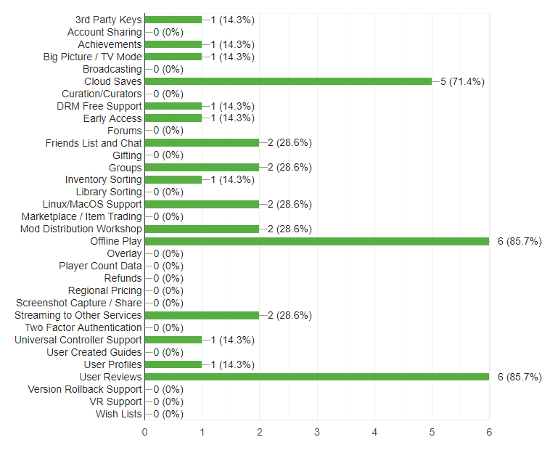

Figure 2: Selected features from users who did not have previous experience with the Epic Games Store.

The participants who had not used Epic Games Store before were questioned about using other video game digital platforms. The responders answered that six of them have used Valve's Steam (85.7%), four of them have used EA's Origin (57.1%), three of them CD Project's GOG (42.9%), and one for each other selection: None, Uplay Store and PS Store (14.3%). These users were also given features to be rated. The highest rated features were Offline Play (six votes, 85.7%), User Reviews (six votes, 85.7%) and Cloud Saves (five votes, 71.4%). The other features had greater variance.

From survey data two personas were designed to reflect users’ motivations and goals.

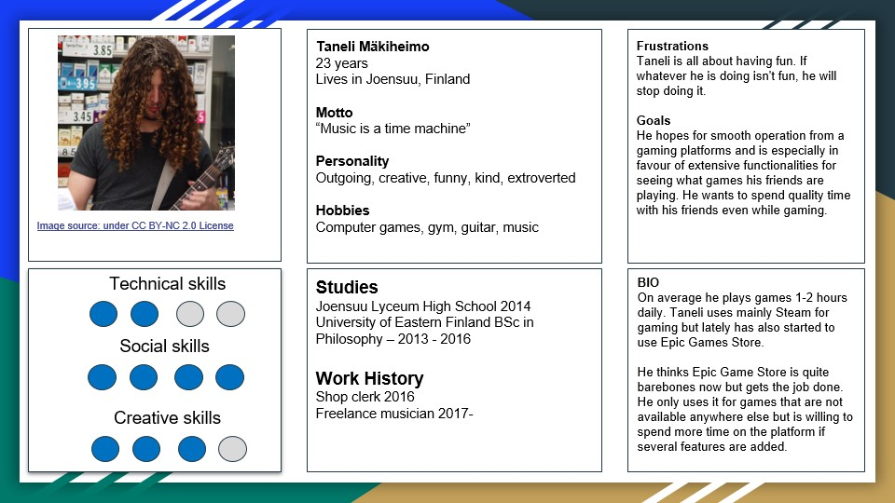

Picture 1: First user persona – Taneli Mäkiheimo [3].

From Taneli's personality store's social aspects are highlighted. It is also stated that missing features are not always stopping people using some services, if there are no options (Epic Games Store has exclusive game distribution rights to some games or publishers, so they are only available to buy and play in their store).

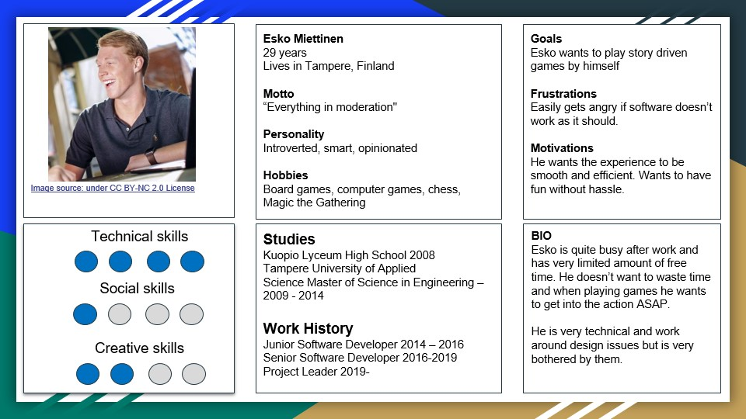

Picture 2: Second user persona – Esko Miettinen [4].

Esko is more demanding user when it comes to how he wants to spend his time. His own personal experience with technical and user experience design have created strong opinions about user experiences. He is likely to be less forgiving when it comes to bad design solutions, and the lack of features (as showcased in Epic Games Store) will probably negatively affect user's experience with the platform.

ACTIONABLE RECOMMENDATIONS

The need for friend lists and chat is related to a gaming platform's network effect: the users are on a certain platform because their friends are there too. The chat functionality is especially used for online multiplayer games or outside the games either by using a microphone or by typing text. Having voice chat on Epic Games Store would be good for the network effect especially on games that do not have the functionality already.

The users want to play games with their friends and share their experiences on a same platform. They also want to know what their friends of think of all the available games, which would make proper user reviews necessary. Therefore, implementing friends list, voice chat and user reviews would increase Epic Games Store's network effect and user engagement.

Refunds and support for DRM-free games improve the store from a consumer perspective. DRM technologies have been considered highly controversial because of possible negative effects on the gaming experience. These effects can be things such as decreased technical performance leading to heavily dropping frame rates, inability to play the games due to always-online requirements or inability to play the game on other operating systems. DRM has been also criticized for being counter-productive in terms of preventing piracy and hampering the gaming experiences for customers who have bought the game legally. From a consumer perspective the store improves in terms of reliability if refunds and support for DRM-free games are implemented.

Early Access games cannot be considered a factor which improves user experience. However, it increases the platform's selection of games which in turn increases the amount of user engagement. The downside is usually heavily varying quality of Early Access games which can lead to good indie games appearing on the platform or in turn poor-quality games being released. Epic will likely need to implement a quality certification system for Early Access games. Therefore, recommending Early Access games for Epic Games Store is arguable.

The most wished features create a good baseline for what improvements Epic should make for its store. Friends list, chat and user reviews improve the store's social side, whereas support for DRM-free games and refunds improves the store from a consumer perspective. All those features are also on Steam, which naturally explains why they also are the most wished features for Epic Games Store. As the longest-running digital game store and platform, Steam has set the standard for a basic functionality expected from a gaming platform. Therefore, implementing the most wished features would likely raise Epic Games Store on the same level with Steam, improve the user experience and increase customer engagement.

FUNCTIONALITY COMPARISON

To illustrate the usability differences between the Epic Games Store and Steam, the two were compared in three different tasks, each repeated twice:

* Purchasing three games (Borderlands 3, Rainbow Six Siege and Assassin’s Creed Odyssey)
* Finding five games that are on sale
* Reading one positive and one negative review of a game

The purchasing task consisted of searching for the three aforementioned games via the search function of each platform, followed by individually “purchasing” them on the Epic Games Store, and adding all three games to the shopping cart and then “purchasing” it on Steam. The purchase process was not fully completed but a period of roughly three seconds was waited to simulate the time required to complete the purchase.

Finding five discounted games required going to the store front page and displaying five products that were clearly marked as being on sale.

The final task was to find one positive and one negative review of a game within the store page.

Full footage of the tests can be found within the file “Comparison videos” of the project files. The timed results of these tests are shown in Table 1:

|  |  |  |  |  |
| --- | --- | --- | --- | --- |
|  | **Steam run 1** | **Steam run 2** | **EGS run 1** | **EGS run 2** |
| **Task 1** | 1:19 | 1:14 | 1:29 | 1:23 |
| **Task 2** | 0:19 | 0:19 | 0:21 | 0:15 |
| **Task 3** | 0:57 | 0:37 | - | - |

Table 1 Time taken in minutes and seconds

The purchase of 3 games required ten and nine seconds more on the Epic Games Store when compared to Steam, a 13% and 12% increase, respectively. This difference can at least in part be attributed to the user being required to purchase each game individually.

Finding five discounted games was a virtually identical experience on both platforms. Each had a clearly labeled section for games on sale. It should be noted, however, that the situation changed before testing began. The “Epic Mega Sale” was added on May 14th, 2020. Before this, games were only grouped by genre and games with a discounted price could only be found by going through the catalog, with no section specifically designated for them.

The ability to read reviews of games by users is currently not available on the Epic Games Store, shown by the lack of results.

These tests indicate that the lack of common functions in the Epic Games Store both hinder the user experience and deprive users of some functionality altogether.

PROTOTYPING

The creation of mockups was started after collecting answers to the questionnaire and seeing what features were wanted. From these features, ones that could be reasonably made into mockups were selected. As mentioned before, user reviews were a wanted or appreciated feature amongst the participants to the questionnaire. This was why user reviews were selected as a feature for creation of mockups. Another feature that was selected was a shopping cart function. This was also requested because it would make the process of purchasing multiple products at once much easier than is currently possible with Epic Games Store and it is a feature that is fundamental to online shopping platforms. These features were an improvement to the Epic Games Store’s usability and improved user experience.

PowerPoint was selected as the tool for creating the mockups. One reason for this was because it is a tool that was familiar. It also contained the necessary tools and features for creating the mockups. PowerPoint also made it possible to keep parts of the Epic Games Store’s UI that the added features did not affect and it was decided that we would not change the original UI too much if it was not necessary. Epic Games Store’s UI is quite simplistic with not many elements, which it makes it less cluttered. Keeping the similar feel and look was a starting point for our features as well.

In PowerPoint, for the creation of the mockups, tools such as shapes, text box and format painter were used. Shapes were used for creating the rectangles for the new features. Text boxes were used for adding new text. Format painter was very useful when selecting similar colors that were used by Epic Games Store to keep the similar look and feel in the added features. Other tool that was used was Windows’ screen shot tool to get the initial layout of EGS and pictures of the games in the store. Common Creative pictures were used for the gift, thumbs up and thumbs down pictures.

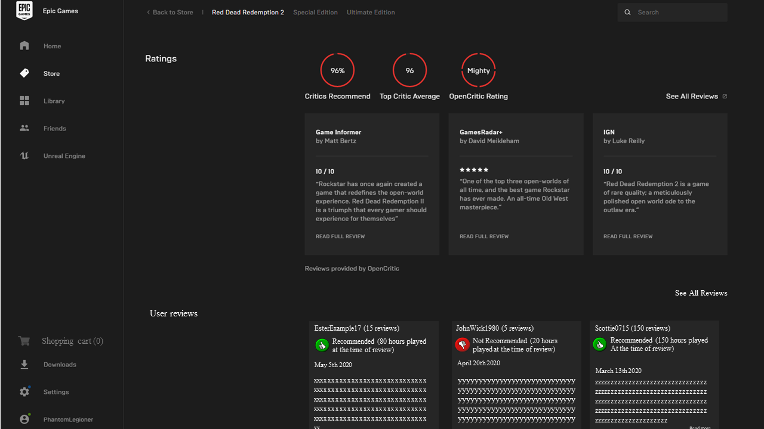

Picture 3: User reviews added in the design to Epic Games Store.



Picture 4: Shopping cart functionality prototype.

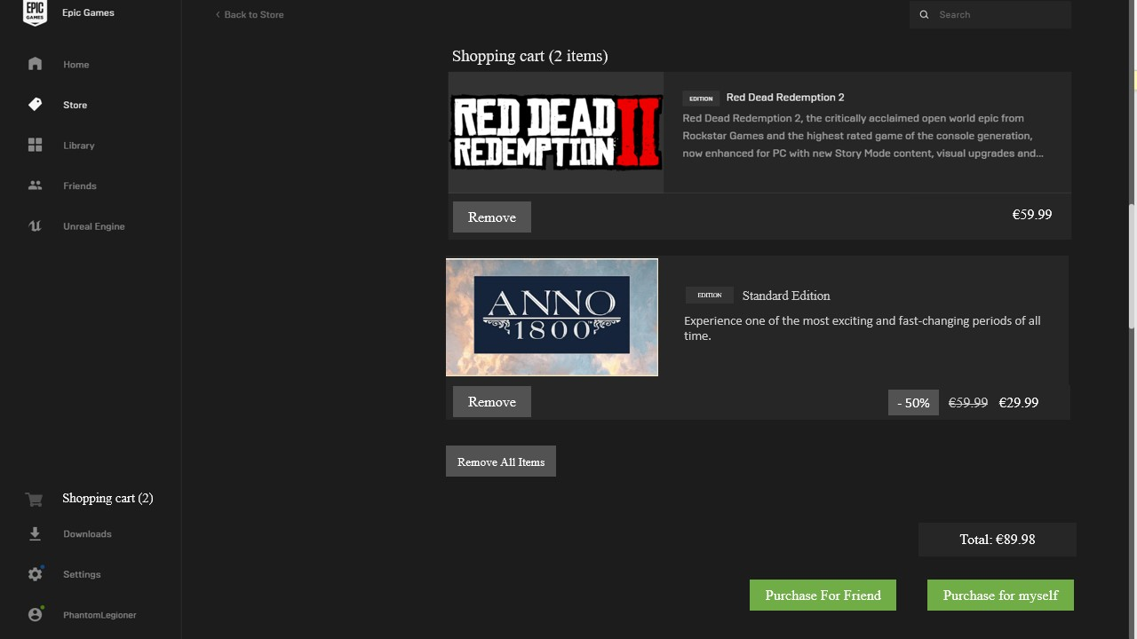

Picture 5: Prototype of inside of the shopping cart, including sale information, multiple items, and gifting.

After creating initial mockups, they were shown and demonstrated to two participants in a session by using Wizard of Oz method. The initial mockups were then modified according to the feedback given by the two users in the interview to create the final versions.

Two users were interviewed to give their evaluations about the new design and to test functionality with the Wizard of Oz technique [4]. Users were both male (23 years and 20 years old). Both users had previous experience with the Epic Games Store and Steam. The users were interviewed using Discord VoIP service’s call and screenshare functions. The answers were written based on users' verbal comments and checked with the users after interview to avoid misinterpretation.

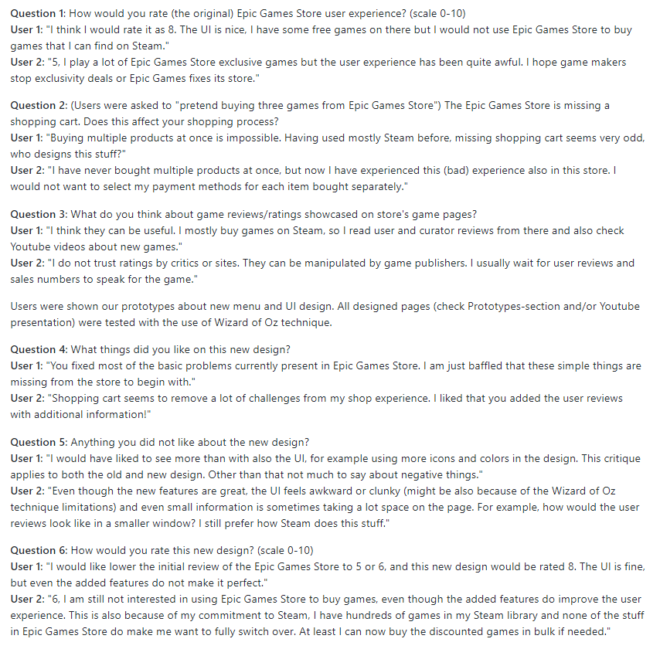

Picture 6: User interviews.

CONCLUSION

To conclude our journey about reviewing the Epic Games Store user experience and creating new designs to possibly enhance this experience, we noticed a lot of expectations from video game online distribution platforms. Steam as an original online video game store has set the standard for what is expected from a game platform. There were three major problems deduced in Epic Games Store:

* Basic functionality / features missing - Shopping cart, gifting, and navigation problems. Having better shop functionality overall could bring direct financial benefits to Epic Games - why would you want to make buying process difficult?
* Social experience - The need for good friends list and chat and other social features showcase the network effect - the users want to be where their friends are. Implementing social features enhances the network effect.
* Pro-consumer methods - Users enjoy when they are treated well. Pro-consumer methods involve features like DRM-free support and refunds. When these features are implemented, users are probably more inclined to buy things from the store.

The Epic Games Store is not broken, but it requires major improvements to make it a primary store for users to use. Epic Games Store has gained a burst of users by making exclusive deals with game publishers (games can only be bought from Epic Games Store) but this may only be a temporary solution. Improving the user experience will bring longevity to the store. We hope to see even some of these features to be implemented soon. The study also provided some insight overall about user preferences in video game online distribution, that can be applied to any online store.

ACKNOWLEDGMENTS

We want to thank our lecturer Roman Bednarik for guidance and instructions regarding the project work. This project was part of the University of Eastern Finland course “User-Centered Design” and many of techniques used in this study were directly influenced by the course material.

REFERENCES

[1] <https://www.statista.com/statistics/746230/fortnite-players/> - Page visited 19.5.2020.

[2] <https://www.gamesradar.com/how-many-people-play-fortnite/> - Page visited 19.5.2020.

[3] J. Preece, Y. Rogers, and H. Sharp, *Interaction design beyond human-computer interaction*. Chichester: Wiley, 2018, pp. 238 [Online]. Available: <https://moodle.uef.fi/pluginfile.php/3167151/mod_resource/content/1/Interaction_design_p22_247.pdf>

[4] F. Harwood, “Wizard of Oz testing – a method of testing a system that does not yet exist.,” *Simple Usability*, 30-Aug-2018. [Online]. Available: https://www.simpleusability.com/inspiration/2018/08/wizard-of-oz-testing-a-method-of-testing-a-system-that-does-not-yet-exist/. [Accessed: 19-May-2020].

[5] Picture for persona taken from <https://search.creativecommons.org/photos/84b2284c-74ba-4a9b-bd15-e5a7effd71e2> under the Creative Commons license.

[6] Picture for persona taken from <https://search.creativecommons.org/photos/6525e092-0255-439d-bc56-d05a684a9d75> under the Creative Commons license.

[7] <https://www.usabilitybok.org/wizard-of-oz> - Page visited 19.5.2020.

[8] Picture for thumbs down taken from <https://commons.wikimedia.org/wiki/Category:Thumbs_down_icons#/media/File:Circle-Thumb-Down.png> under the Creative Commons license.

[9] Picture for thumbs up taken from

<https://commons.wikimedia.org/wiki/Category:Thumbs_up_icons#/media/File:Circle-Thumb.png> under the Creative Commons license.

[10] Picture for shopping cart taken from

<https://upload.wikimedia.org/wikipedia/commons/5/5a/Antu_amarok_cart_view.svg> under the Creative Commons licenseConference Name:ACM Woodstock conference

Conference Short Name:WOODSTOCK’18

Conference Location:El Paso, Texas USA

ISBN:978-1-4503-0000-0/18/06

Year:2018

Date:June

Copyright Year:2018

Copyright Statement:rightsretained

DOI:10.1145/1234567890

RRH: F. Surname et al.

Price:$15.00